A lattice-based forward secure IBE scheme for Internet of things
Novel Approach: The main approach is to integrate secure query-based trust model followed by fs-IBE encryption
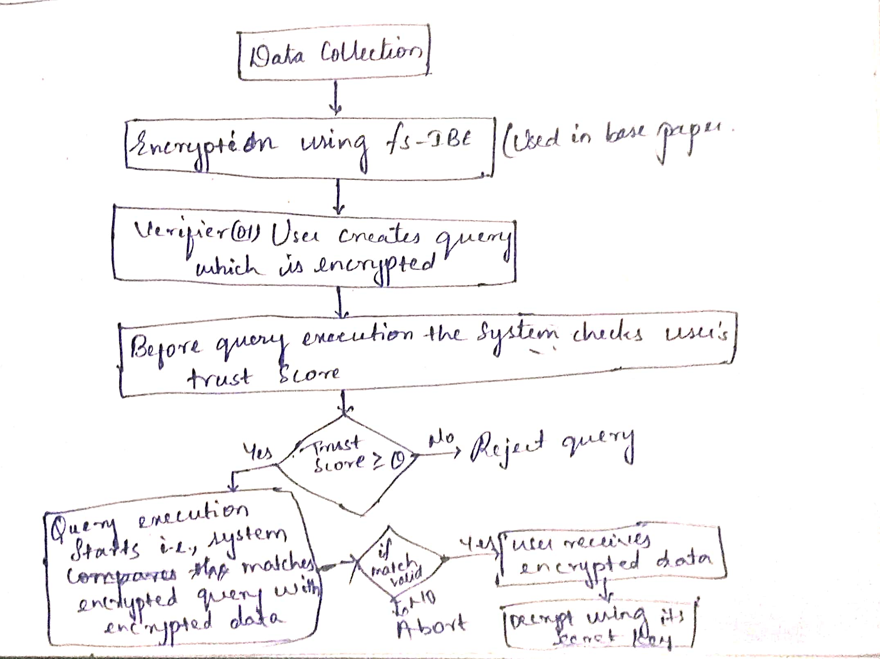
Post quantum cryptographic methods for the novel approach:
- For data encryption and query encryption: Use fs-IBE method which is used in the base paper.
- For trust verification: Use dilithium-3 for digital signature.
The encryption keys are distributed on epoch based manner.
Along with the query the user also signs the data which is used for trust verification of the user.
The queries are also epoch bound.
Results to be calculated:
- Data encryption time
- Query encryption time
- Data decryption time
- Query execution latency
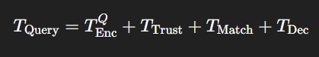
- Query throughput
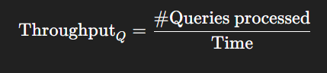
- Overall model throughput
- Overall model latency
- False trust acceptance rate
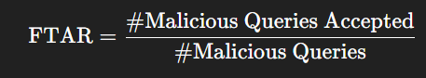
Reference papers:
- Base paper
- An Efficient and Forward-Secure Lattice-Based Searchable Encryption Scheme for the Big-Data Era
- Enabling efficient and secure health data sharing for Healthcare IoT systems
- Secure and trusted data sharing in smart healthcare using blockchain and IoT integration

